FoxEats

Human Cyborgs

August Alexander, Sydonya Miller, Andrej Opancic

Introduction:  
  
Project Name: FoxEats

Project Purpose: Creating a database & platform for students to order food from the different options on-campus and get it delivered, similar to the 'MobileOrder' app that we already have on-campus. This is also similar to how UberEats or Grubhub operates. The platform will have a login & password checked by FoxID to make sure it is the correct user. We will also have the user's building to know where the food will be delivered, as well as contact numbers for any troubles with the orders. Each dining service will have different food options with their own prices, descriptions, and ratings. We will have a status if the dining service is open, as well as updates whether or not the food is ready, delivered, or in the process of being made. After the user picked out their order, they will have to pay with their payment of their choice (foxID, or credit card) and then the database will process the math associated with the balance and cost. This will give the user an order ID and receipt. If the user wishes to reorder the same meal, they can simply visit their order history and order again.

Target User: Students will be using our platform, as well as dining services to communicate with the students for any problems with the orders. We want our platform to be descriptive for the user and streamline the delivery process.

Data to be used: FoxID, Credit_Card, Balance, Username, Password, Contact_Number, Building, Dining_Service, Food_Category, Food_Option, Price, Food_Description, Rating, Status, Update, Order_ID, Order_History

Data Sensitivity: We will not use any FoxIDs or Credit_Card numbers used by anyone, they will be randomly generated.

Data Collection: We will gather the data from current dining service options, as well as statistics, and sort of base our app from the 'MobileOrder' framework.

Output Design: We currently do not have a design ready in mind, but we know we will have a login page, dining services page, cart page, a payment page that shows a confirmation screen, and finalizes a receipt with all the information required. This will all be done on a website rather than an app.

Methods:

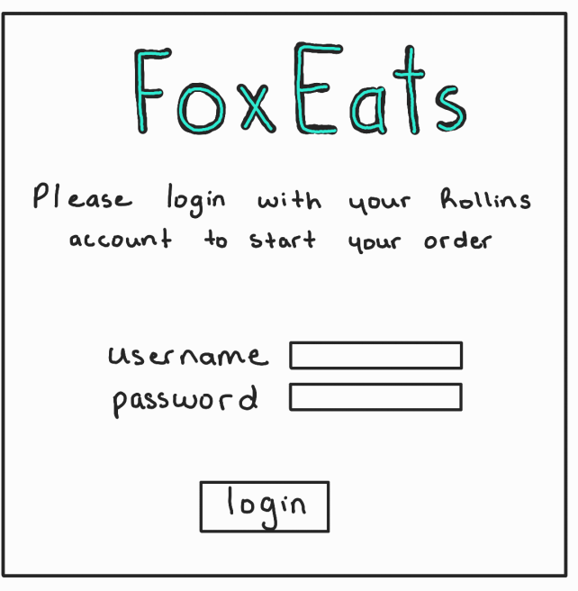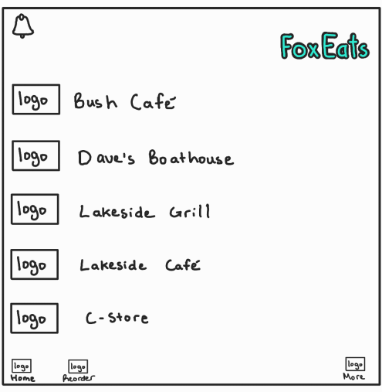

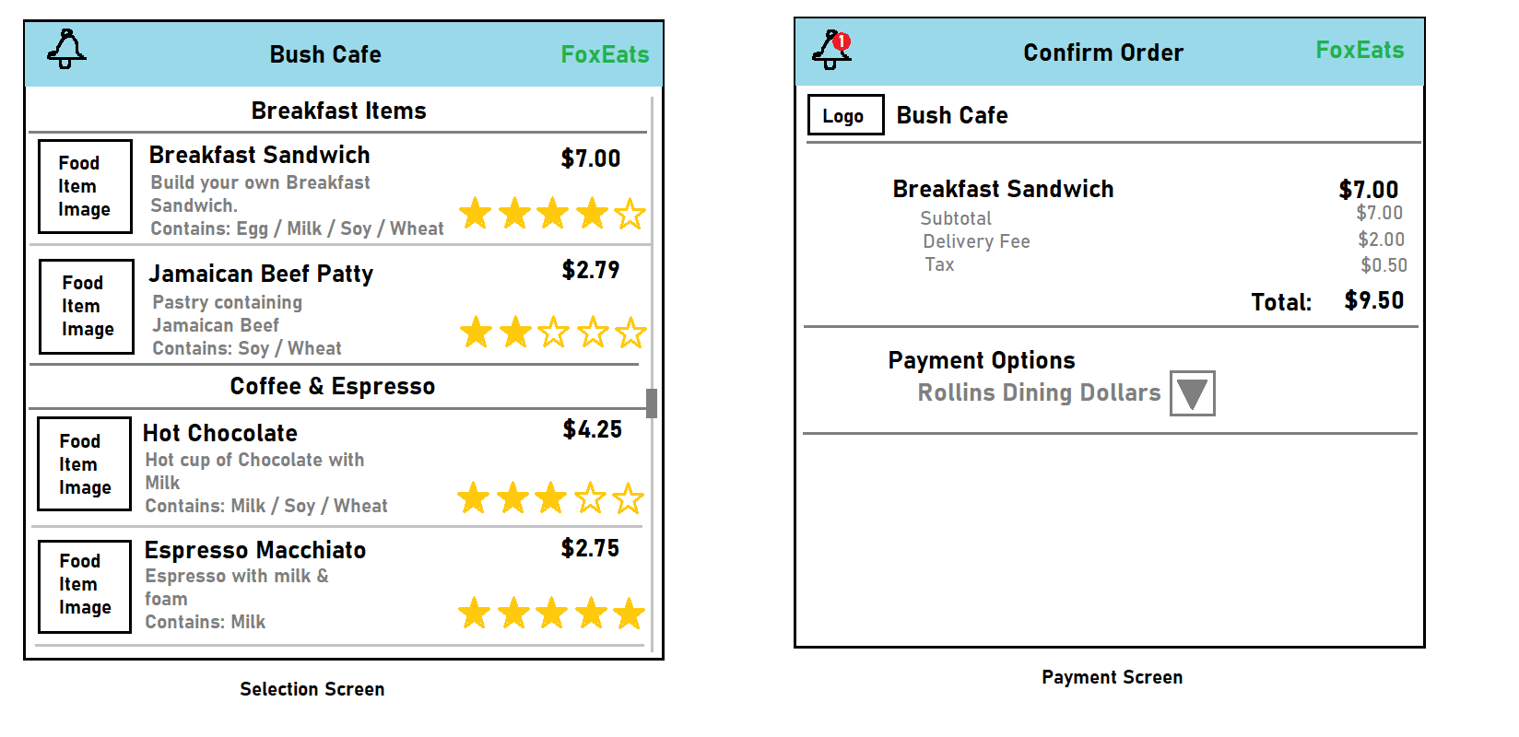

Rest of the methods go here

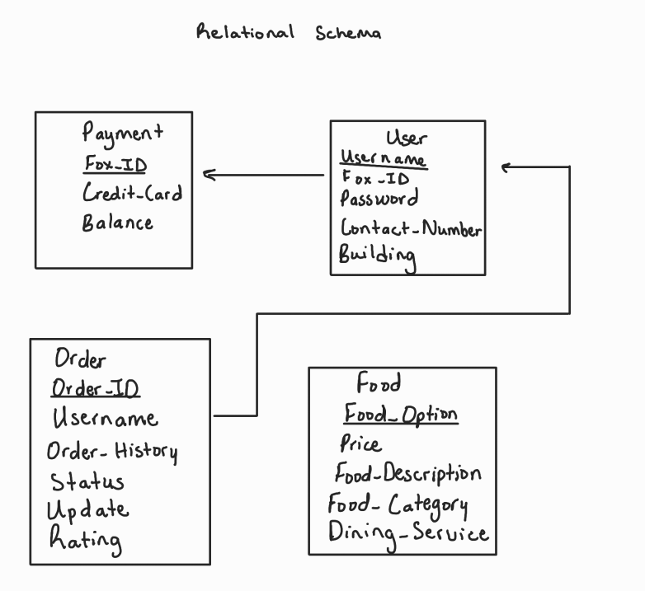

Codes:

Connection

<?php

error_reporting(E_ALL);

ini_set('display_errors', 1);

$servername = "localhost";

$username = "root";

$password = "";

$dbname = "FoxEats";

$conn = mysqli_connect($servername, $username, $password, $dbname);

if (!$conn) {

die("Connection failed: " . mysqli_connect_error());

}

?>

Login

<?php

error_reporting(E_ALL);

ini_set('display_errors', 1);

session_start();

include 'db_connection.php';

if ($_SERVER["REQUEST_METHOD"] == "POST") {

$username = $_POST["username"];

$password = $_POST["password"];

// Fetch the user's record from the database

$query = "SELECT * FROM User WHERE Username='$username'";

$result = mysqli_query($conn, $query);

if (mysqli_num_rows($result) == 1) {

$user = mysqli_fetch_assoc($result);

// Compare the password entered by the user with the password stored in the database

if ($password == $user['Password']) {

// Passwords match, set session variable and redirect

$_SESSION["username"] = $username;

header("Location: db_home.php");

exit; // Add exit to prevent further execution

} else {

// Passwords don't match, show error

$error = "Username or password is incorrect.";

}

} else {

// User not found, show error

$error = "Username or password is incorrect.";

}

}

?>

<!DOCTYPE html>

<html lang="en">

<head>

<meta charset="UTF-8">

<meta name="viewport" content="width=device-width, initial-scale=1.0">

<title>Login</title>

<style>

body {

font-family: Arial, sans-serif;

}

.container {

text-align: center;

margin-top: 50px;

}

.login-box {

width: 500px;

padding: 60px;

border: 3px solid #ccc;

border-radius: 15px;

box-shadow: 0 0 30px rgba(0, 0, 0, 0.1);

text-align: center; /* Center align */

display: inline-block;

}

h1 {

color: turquoise;

font-size: 72px; /* 2 times bigger than previous */

margin-bottom: 20px;

}

h3 {

color: black; /* Change color to black */

font-size: 24px;

margin-top: 0; /* Remove default margin */

margin-bottom: 20px;

}

label {

font-weight: bold;

font-size: 22px;

text-align: left; /* Align left */

display: block; /* Make each label on a new line */

}

input[type="text"],

input[type="password"],

button {

width: 100%;

padding: 15px;

margin-top: 20px;

font-size: 20px;

border-radius: 8px;

border: 2px solid #ccc;

box-sizing: border-box;

}

button {

background-color: turquoise;

color: white;

cursor: pointer;

}

button:hover {

background-color: #48D1CC;

}

.error {

color: red;

font-size: 20px;

}

</style>

<script type="text/javascript">

function blockSpecialChar(e){

var k;

document.all ? k = e.keyCode : k = e.which;

return ((k > 64 && k < 91) || (k > 96 && k < 123) || k == 8 || k == 32 || (k >= 48 && k <= 57));

}

</script>

</head>

<body>

<div class="container">

<h1>FoxEats</h1>

<div class="login-box">

<h3>Please Login with your Rollins Account to Start your Order</h3>

<form action="" method="post">

<label for="username">Username:</label>

<input type="text" id="username" name="username" required onkeypress="return blockSpecialChar(event)"/><br>

<label for="password">Password:</label>

<input type="password" id="password" name="password" required onkeypress="return blockSpecialChar(event)"/><br>

<button type="submit">Login</button>

</form>

<?php if (isset($error)): ?>

<p class="error"><?= $error ?></p>

<?php endif; ?>

</div>

</div>

<script>

// Disable forward navigation until user logs in

window.onload = function() {

disableForwardNavigation();

};

function disableForwardNavigation() {

var links = document.querySelectorAll('a[onclick="window.history.forward()"]');

for (var i = 0; i < links.length; i++) {

links[i].onclick = function() {

alert("Please login to proceed.");

return false;

};

}

}

</script>

</body>

</html>

Home

<!DOCTYPE html>

<html lang="en">

<head>

<meta charset="UTF-8">

<meta name="viewport" content="width=device-width, initial-scale=1.0">

<title>Home | FoxEats</title>

<style>

body {

font-family: Arial, sans-serif;

margin: 0;

padding: 0;

}

.container {

max-width: 1200px;

margin: 0 auto;

padding: 20px;

}

header {

background-color: turquoise;

padding: 10px;

text-align: right;

color: white;

}

.restaurants {

margin-top: 20px;

text-align: center;

}

.restaurant {

margin-bottom: 20px;

padding: 20px;

border: 1px solid #ccc;

border-radius: 10px;

box-shadow: 0 0 10px rgba(0, 0, 0, 0.1);

}

h1 {

color: turquoise;

text-align: center;

}

.restaurant h2 {

margin-top: 0;

}

.restaurant p {

margin-bottom: 0;

}

.restaurant a {

text-decoration: none;

color: black;

}

</style>

</head>

<body>

<header>

<div class="container">

<h1>FoxEats</h1>

</div>

</header>

<div class="container">

<h1>Available Restaurants</h1>

<div class="restaurants">

<div class="restaurant">

<a href="indexFoxEats.php">

<h2>Bush Cafe</h2>

</a>

</div>

<div class="restaurant">

<a href="daves.php">

<h2>Dave's Boathouse</h2>

</a>

</div>

<div class="restaurant">

<a href="grill.php">

<h2>Lakeside Grill</h2>

</a>

</div>

<div class="restaurant">

<a href="cafe.php">

<h2>Lakeside Cafe</h2>

</a>

</div>

<div class="restaurant">

<a href="cstore.php">

<h2>C-Store</h2>

</a>

</div>

</div>

</div>

</body>

</html>

Bush Menu

<?php

error_reporting(E_ALL);

ini_set('display_errors', 1);

include 'db_connection.php';

$query = "SELECT Food_Option, Food_Description, Price FROM Food LIMIT 2";

$result = mysqli_query($conn, $query);

?>

<!DOCTYPE html>

<html lang="en">

<head>

<meta charset="UTF-8">

<meta name="viewport" content="width=device-width, initial-scale=1.0">

<title>Bush Cafe Menu | FoxEats</title>

<style>

body {

font-family: Arial, sans-serif;

margin: 0;

padding: 0;

}

.container {

max-width: 800px;

margin: 50px auto;

padding: 20px;

border: 1px solid #ccc;

border-radius: 10px;

box-shadow: 0 0 10px rgba(0, 0, 0, 0.1);

text-align: center;

}

header {

background-color: turquoise;

padding: 10px;

text-align: center;

color: white;

border-radius: 10px 10px 0 0;

}

.menu-item {

margin-bottom: 20px;

padding: 20px;

border: 1px solid #ccc;

border-radius: 10px;

box-shadow: 0 0 5px rgba(0, 0, 0, 0.1);

}

h2 {

margin-top: 0;

color: turquoise;

}

p {

margin-bottom: 0;

}

.back-btn {

display: inline-block;

background-color: #3cb0fd;

color: white;

padding: 10px 20px;

border: none;

border-radius: 5px;

cursor: pointer;

text-decoration: none;

margin-top: 20px;

}

.back-btn:hover {

background-color: #1e87d4;

}

</style>

</head>

<body>

<header>

<h1>Bush Cafe Menu</h1>

</header>

<div class="container">

<?php while ($row = mysqli_fetch_assoc($result)): ?>

<div class="menu-item">

<h2><?= $row['Food_Option'] ?></h2>

<p><?= $row['Food_Description'] ?></p>

<p><?= $row['Price'] ?></p>

<a href="payment.php?food=<?= urlencode($row['Food_Option']) ?>" class="btn">Order</a>

</div>

<?php endwhile; ?>

<!-- Back button -->

<a href="db_home.php" class="back-btn">Back</a>

</div>

</body>

</html>

Daves Menu

<?php

error_reporting(E_ALL);

ini_set('display_errors', 1);

include 'db_connection.php';

$query = "SELECT Food_Option, Food_Description, Price FROM Food LIMIT 2, 2";

$result = mysqli_query($conn, $query);

?>

<!DOCTYPE html>

<html lang="en">

<head>

<meta charset="UTF-8">

<meta name="viewport" content="width=device-width, initial-scale=1.0">

<title>Dave's Boathouse Menu | FoxEats</title>

<style>

body {

font-family: Arial, sans-serif;

margin: 0;

padding: 0;

}

.container {

max-width: 800px;

margin: 50px auto;

padding: 20px;

border: 1px solid #ccc;

border-radius: 10px;

box-shadow: 0 0 10px rgba(0, 0, 0, 0.1);

text-align: center;

}

header {

background-color: turquoise;

padding: 10px;

text-align: center;

color: white;

border-radius: 10px 10px 0 0;

}

.menu-item {

margin-bottom: 20px;

padding: 20px;

border: 1px solid #ccc;

border-radius: 10px;

box-shadow: 0 0 5px rgba(0, 0, 0, 0.1);

}

h2 {

margin-top: 0;

color: turquoise;

}

p {

margin-bottom: 0;

}

.back-btn {

display: inline-block;

background-color: #3cb0fd;

color: white;

padding: 10px 20px;

border: none;

border-radius: 5px;

cursor: pointer;

text-decoration: none;

margin-top: 20px;

}

.back-btn:hover {

background-color: #1e87d4;

}

</style>

</head>

<body>

<header>

<h1>Dave's Boathouse Menu</h1>

</header>

<div class="container">

<?php while ($row = mysqli_fetch_assoc($result)): ?>

<div class="menu-item">

<h2><?= $row['Food_Option'] ?></h2>

<p><?= $row['Food_Description'] ?></p>

<p><?= $row['Price'] ?></p>

<a href="payment.php?food=<?= urlencode($row['Food_Option']) ?>" class="btn">Order</a>

</div>

<?php endwhile; ?>

<!-- Back button -->

<a href="db_home.php" class="back-btn">Back</a>

</div>

</body>

</html>

Lakeside Grill Menu

<?php

error_reporting(E_ALL);

ini_set('display_errors', 1);

include 'db_connection.php';

$query = "SELECT Food_Option, Food_Description, Price FROM Food LIMIT 4, 2"; // Skip the first 4 items and select the next 2

$result = mysqli_query($conn, $query);

?>

<!DOCTYPE html>

<html lang="en">

<head>

<meta charset="UTF-8">

<meta name="viewport" content="width=device-width, initial-scale=1.0">

<title>Lakeside Grill Menu | FoxEats</title>

<style>

body {

font-family: Arial, sans-serif;

margin: 0;

padding: 0;

}

.container {

max-width: 800px;

margin: 50px auto;

padding: 20px;

border: 1px solid #ccc;

border-radius: 10px;

box-shadow: 0 0 10px rgba(0, 0, 0, 0.1);

text-align: center;

}

header {

background-color: turquoise;

padding: 10px;

text-align: center;

color: white;

border-radius: 10px 10px 0 0;

}

.menu-item {

margin-bottom: 20px;

padding: 20px;

border: 1px solid #ccc;

border-radius: 10px;

box-shadow: 0 0 5px rgba(0, 0, 0, 0.1);

}

h2 {

margin-top: 0;

color: turquoise;

}

p {

margin-bottom: 0;

}

.back-btn {

display: inline-block;

background-color: #3cb0fd;

color: white;

padding: 10px 20px;

border: none;

border-radius: 5px;

cursor: pointer;

text-decoration: none;

margin-top: 20px;

}

.back-btn:hover {

background-color: #1e87d4;

}

</style>

</head>

<body>

<header>

<h1>Lakeside Grill Menu</h1>

</header>

<div class="container">

<?php while ($row = mysqli_fetch_assoc($result)): ?>

<div class="menu-item">

<h2><?= $row['Food_Option'] ?></h2>

<p><?= $row['Food_Description'] ?></p>

<p><?= $row['Price'] ?></p>

<a href="payment.php?food=<?= urlencode($row['Food_Option']) ?>" class="btn">Order</a>

</div>

<?php endwhile; ?>

<!-- Back button -->

<a href="db_home.php" class="back-btn">Back</a>

</div>

</body>

</html>

Lakeside Cafe Menu

<?php

error_reporting(E_ALL);

ini_set('display_errors', 1);

include 'db_connection.php';

$query = "SELECT Food_Option, Food_Description, Price FROM Food LIMIT 6, 2"; // Skip the first 6 items and select the next 2

$result = mysqli_query($conn, $query);

?>

<!DOCTYPE html>

<html lang="en">

<head>

<meta charset="UTF-8">

<meta name="viewport" content="width=device-width, initial-scale=1.0">

<title>Lakeside Cafe Menu | FoxEats</title>

<style>

body {

font-family: Arial, sans-serif;

margin: 0;

padding: 0;

}

.container {

max-width: 800px;

margin: 50px auto;

padding: 20px;

border: 1px solid #ccc;

border-radius: 10px;

box-shadow: 0 0 10px rgba(0, 0, 0, 0.1);

text-align: center;

}

header {

background-color: turquoise;

padding: 10px;

text-align: center;

color: white;

border-radius: 10px 10px 0 0;

}

.menu-item {

margin-bottom: 20px;

padding: 20px;

border: 1px solid #ccc;

border-radius: 10px;

box-shadow: 0 0 5px rgba(0, 0, 0, 0.1);

}

h2 {

margin-top: 0;

color: turquoise;

}

p {

margin-bottom: 0;

}

.back-btn {

display: inline-block;

background-color: #3cb0fd;

color: white;

padding: 10px 20px;

border: none;

border-radius: 5px;

cursor: pointer;

text-decoration: none;

margin-top: 20px;

}

.back-btn:hover {

background-color: #1e87d4;

}

</style>

</head>

<body>

<header>

<h1>Lakeside Cafe Menu</h1>

</header>

<div class="container">

<?php while ($row = mysqli_fetch_assoc($result)): ?>

<div class="menu-item">

<h2><?= $row['Food_Option'] ?></h2>

<p><?= $row['Food_Description'] ?></p>

<p><?= $row['Price'] ?></p>

<a href="payment.php?food=<?= urlencode($row['Food_Option']) ?>" class="btn">Order</a>

</div>

<?php endwhile; ?>

<!-- Back button -->

<a href="db_home.php" class="back-btn">Back</a>

</div>

</body>

</html>

CStore Menu

<?php

error_reporting(E_ALL);

ini_set('display_errors', 1);

include 'db_connection.php';

$query = "SELECT Food_Option, Food_Description, Price FROM Food LIMIT 8, 2"; // Skip the first 8 items and select the next 2

$result = mysqli_query($conn, $query);

?>

<!DOCTYPE html>

<html lang="en">

<head>

<meta charset="UTF-8">

<meta name="viewport" content="width=device-width, initial-scale=1.0">

<title>C-Store Menu | FoxEats</title>

<style>

body {

font-family: Arial, sans-serif;

margin: 0;

padding: 0;

}

.container {

max-width: 800px;

margin: 50px auto;

padding: 20px;

border: 1px solid #ccc;

border-radius: 10px;

box-shadow: 0 0 10px rgba(0, 0, 0, 0.1);

text-align: center;

}

header {

background-color: turquoise;

padding: 10px;

text-align: center;

color: white;

border-radius: 10px 10px 0 0;

}

.menu-item {

margin-bottom: 20px;

padding: 20px;

border: 1px solid #ccc;

border-radius: 10px;

box-shadow: 0 0 5px rgba(0, 0, 0, 0.1);

}

h2 {

margin-top: 0;

color: turquoise;

}

p {

margin-bottom: 0;

}

.back-btn {

display: inline-block;

background-color: #3cb0fd;

color: white;

padding: 10px 20px;

border: none;

border-radius: 5px;

cursor: pointer;

text-decoration: none;

margin-top: 20px;

}

.back-btn:hover {

background-color: #1e87d4;

}

</style>

</head>

<body>

<header>

<h1>C-Store Menu</h1>

</header>

<div class="container">

<?php while ($row = mysqli_fetch_assoc($result)): ?>

<div class="menu-item">

<h2><?= $row['Food_Option'] ?></h2>

<p><?= $row['Food_Description'] ?></p>

<p><?= $row['Price'] ?></p>

<a href="payment.php?food=<?= urlencode($row['Food_Option']) ?>" class="btn">Order</a>

</div>

<?php endwhile; ?>

<!-- Back button -->

<a href="db_home.php" class="back-btn">Back</a>

</div>

</body>

</html>

Payment Screen

<?php

session_start();

// Include the database connection

include 'db_connection.php';

// Initialize an empty array to store selected food items

if (!isset($_SESSION['selectedItems'])) {

$_SESSION['selectedItems'] = [];

}

$selectedItems = $_SESSION['selectedItems'];

// Add new selected item to the list if submitted from the menu

if (isset($_GET["food"])) {

$selectedFood = $_GET["food"];

array_push($selectedItems, $selectedFood);

$_SESSION['selectedItems'] = $selectedItems;

}

// Remove selected item from the list if requested

if (isset($_GET["remove"])) {

$item_to_remove = $_GET["remove"];

$key = array_search($item_to_remove, $selectedItems);

if ($key !== false) {

unset($selectedItems[$key]);

$_SESSION['selectedItems'] = array_values($selectedItems); // Reindex the array

}

}

// Remove all selected items if requested

if (isset($_POST["remove_all"])) {

$_SESSION['selectedItems'] = [];

header("Location: db_home.php");

exit;

}

// Calculate total price for all selected items

$totalPrice = 0;

foreach ($selectedItems as $item) {

// Fetch price for each item from the database

$price = getPriceFromDatabase($item, $conn); // Pass the database connection

$totalPrice += $price;

}

// Function to fetch price from database

function getPriceFromDatabase($item, $conn) {

// Query to fetch price from the Food table

$query = "SELECT Price FROM Food WHERE Food_Option = '$item'";

$result = mysqli_query($conn, $query);

if (mysqli_num_rows($result) > 0) {

$row = mysqli_fetch_assoc($result);

return $row["Price"];

} else {

return 0; // Return 0 if price not found (handle error as needed)

}

}

?>

<!DOCTYPE html>

<html lang="en">

<head>

<meta charset="UTF-8">

<meta name="viewport" content="width=device-width, initial-scale=1.0">

<title>Confirm Order | FoxEats</title>

<style>

body {

font-family: Arial, sans-serif;

margin: 0;

padding: 0;

}

.container {

max-width: 600px;

margin: 50px auto;

padding: 20px;

border: 1px solid #ccc;

border-radius: 10px;

background-color: #f9f9f9;

}

h1, h2, p {

text-align: center;

}

ul {

list-style: none;

padding: 0;

}

li {

margin-bottom: 10px;

}

.remove-link {

color: #333;

text-decoration: none;

margin-left: 10px;

}

.btn-container {

text-align: center;

margin-top: 20px;

}

.btn-container .btn {

background-color: turquoise;

color: white;

padding: 10px 20px;

border: none;

border-radius: 5px;

cursor: pointer;

text-decoration: none;

margin-right: 10px;

}

.btn-container .btn:hover {

background-color: #3cb0fd;

}

</style>

<script type="text/javascript">

function blockSpecialChar(e){

var k;

document.all ? k = e.keyCode : k = e.which;

return ((k > 64 && k < 91) || (k > 96 && k < 123) || k == 8 || k == 32 || k == 45 || (k >= 48 && k <= 57));

}

</script>

</head>

<body>

<header>

<h1>Confirm Order</h1>

</header>

<div class="container">

<?php if (!empty($selectedItems)) : ?>

<h2>Selected Items:</h2>

<form action="" method="post"> <!-- Updated form action -->

<ul id="selectedItems">

<?php

$index = 1;

foreach ($selectedItems as $item) : ?>

<li>

<span><?= $index ?>. </span>

<?= $item ?>

<a href="payment.php?remove=<?= urlencode($item) ?>" class="remove-link" onclick="return confirm('Are you sure you want to remove this item?')">Remove</a>

</li>

<?php

$index++;

endforeach; ?>

</ul>

<p>Total Amount: $<?= $totalPrice ?></p>

<div class="btn-container">

<a href="db_home.php" class="btn">Add More</a>

<button type="submit" name="remove_all" class="btn">Delete Order</button>

<a href="order.php" class="btn">Pay</a>

</div>

</form>

<?php else : ?>

<p>No items selected.</p>

<a href="db_home.php" class="btn">Add Items</a>

<?php endif; ?>

</div>

</body>

</html>

Order

<?php

session_start();

include 'db_connection.php';

if (!isset($_SESSION["username"])) {

header("Location: login.php");

exit;

}

if (isset($_GET["food"])) {

$food = $_GET["food"];

$username = $_SESSION["username"];

$query = "INSERT INTO Orders (Username, Order_History, Status, Update_Time) VALUES ('$username', '$food', 'Preparing', NOW())";

mysqli_query($conn, $query);

}

if ($_SERVER["REQUEST_METHOD"] == "POST") {

$paymentMethod = $_POST["payment-method"];

if ($paymentMethod == "R-Card") {

$foxId = $_POST["foxid"];

// Check if the FoxID exists and matches with the user

$query = "SELECT * FROM User WHERE Fox_ID = '$foxId' AND Username = '{$_SESSION["username"]}'";

$result = mysqli_query($conn, $query);

if (mysqli_num_rows($result) > 0) {

// FoxID matches, proceed to completed.php

header("Location: completed.php");

exit;

} else {

// FoxID does not match or does not exist, display error message

$errorMessage = "Invalid FoxID. Please try again.";

}

} elseif ($paymentMethod == "Credit Card") {

$creditCardNumber = $_POST["credit-card"];

// Check if the Credit Card number exists and matches with the user

$query = "SELECT * FROM Payment WHERE Credit_Card = '$creditCardNumber' AND FoxID = (SELECT Fox_ID FROM User WHERE Username = '{$_SESSION["username"]}') ";

$result = mysqli_query($conn, $query);

if (mysqli_num_rows($result) > 0) {

// Credit Card number exists, proceed to completed.php

header("Location: completed.php");

exit;

} else {

// Credit Card number does not match or does not exist, display error message

$errorMessage = "Invalid Credit Card Number. Please try again.";

}

}

}

?>

<!DOCTYPE html>

<html lang="en">

<head>

<meta charset="UTF-8">

<meta name="viewport" content="width=device-width, initial-scale=1.0">

<title>Select Payment Method | FoxEats</title>

<style>

body {

font-family: Arial, sans-serif;

margin: 0;

padding: 0;

background-color: #f2f2f2; /* Light gray background */

}

.container {

max-width: 600px;

margin: 50px auto;

padding: 20px;

border: 1px solid #ccc;

border-radius: 10px;

box-shadow: 0 0 10px rgba(0, 0, 0, 0.1);

background-color: #fff; /* White background */

}

header {

background-color: turquoise;

padding: 10px;

text-align: center;

color: white;

border-radius: 10px 10px 0 0;

margin-bottom: 20px;

}

h1, p {

text-align: center;

}

.payment-option {

display: flex;

justify-content: center;

gap: 20px;

margin-top: 20px;

}

.payment-option input[type="submit"],

.payment-option input[type="button"] {

background-color: turquoise;

color: white;

padding: 10px 20px;

border: none;

border-radius: 5px;

cursor: pointer;

text-decoration: none;

}

.payment-option input[type="submit"]:hover,

.payment-option input[type="button"]:hover {

background-color: #3cb0fd;

}

/* Styling for the Back button */

.payment-option input[type="button"].back-button {

background-color: turquoise;

}

.payment-option input[type="button"].back-button:hover {

background-color: #3cb0fd;

}

</style>

</head>

<body>

<header>

<h1>Select Payment Method</h1>

</header>

<div class="container">

<p>Please select your payment method:</p>

<form action="<?php echo htmlspecialchars($_SERVER["PHP_SELF"]); ?>" method="post" class="payment-option">

<input type="hidden" name="food" value="<?php echo isset($_GET['food']) ? htmlspecialchars($_GET['food']) : ''; ?>">

<input type="hidden" name="payment-method" id="paymentMethod">

<!-- Back button with the same color as other buttons -->

<input type="button" value="Back" onclick="window.location.href='payment.php'" class="back-button">

<input type="button" value="R-Card" class="payment-button" data-method="R-Card">

<input type="button" value="Credit Card" class="payment-button" data-method="Credit Card">

<br><br>

<div id="foxIdDiv" style="display: none;">

<label for="foxid">Enter FoxID:</label>

<input type="text" id="foxid" name="foxid"><br><br>

                        <input type="submit" value="Proceed">

</div>

<div id="creditCardDiv" style="display: none;">

<label for="credit-card">Enter Credit Card Number:</label>

<input type="text" id="credit-card" name="credit-card"><br><br>

                        <input type="submit" value="Proceed">

</div>

</form>

<?php if (isset($errorMessage)) : ?>

<p style="color: red; text-align: center;"><?php echo $errorMessage; ?></p>

<?php endif; ?>

</div>

<script>

const paymentButtons = document.querySelectorAll('.payment-button');

const paymentForm = document.querySelector('.payment-option');

const foxIdDiv = document.getElementById('foxIdDiv');

const creditCardDiv = document.getElementById('creditCardDiv');

paymentButtons.forEach(button => {

button.addEventListener('click', function() {

const method = this.getAttribute('data-method');

if (method === 'R-Card') {

foxIdDiv.style.display = 'block';

creditCardDiv.style.display = 'none';

} else {

foxIdDiv.style.display = 'none';

creditCardDiv.style.display = 'block';

}

document.getElementById('paymentMethod').value = method;

});

});

</script>

</body>

</html>

Completion

<?php

session_start();

include 'db_connection.php';

if (!isset($_SESSION["username"])) {

header("Location: login.php");

exit;

}

if (isset($_GET["food"])) {

$food = $_GET["food"];

$username = $_SESSION["username"];

$query = "INSERT INTO Orders (Username, Order_History, Status, Update_Time) VALUES ('$username', '$food', 'Received', NOW())";

mysqli_query($conn, $query);

}

?>

<!DOCTYPE html>

<html lang="en">

<head>

<meta charset="UTF-8">

<meta name="viewport" content="width=device-width, initial-scale=1.0">

<title>Order Received | FoxEats</title>

<style>

body {

font-family: Arial, sans-serif;

margin: 0;

padding: 0;

background-color: #f2f2f2; /* Light gray background */

}

.container {

max-width: 600px;

margin: 50px auto;

padding: 60px;

border: 1px solid #ccc;

border-radius: 10px;

box-shadow: 0 0 10px rgba(0, 0, 0, 0.1);

background-color: #fff; /* White background */

position: relative;

}

header {

background-color: turquoise;

padding: 10px;

text-align: center;

color: white;

border-radius: 10px 10px 0 0;

margin-bottom: 20px;

}

h1, p {

text-align: center;

}

footer {

position: absolute;

bottom: 10px;

left: 50%;

transform: translateX(-50%);

}

footer button {

background-color: turquoise;

color: white;

padding: 10px 20px;

border: none;

border-radius: 5px;

cursor: pointer;

text-decoration: none;

}

footer button:hover {

background-color: #3cb0fd;

}

</style>

</head>

<body>

<header>

<h1>Order Received</h1>

</header>

<div class="container">

<p>Thank you for your order. We have received it!</p>

<footer>

<form action="db_home.php" method="get">

<button type="submit">Home</button>

</form>

</footer>

</div>

</body>

</html>

Experiments and Results:

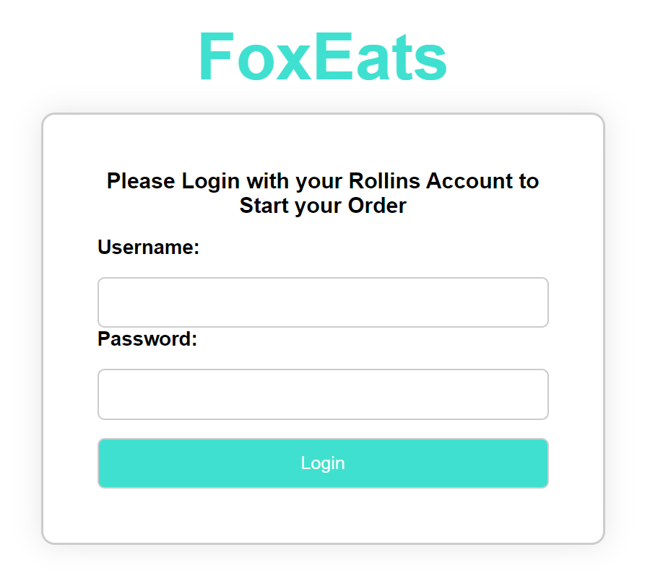

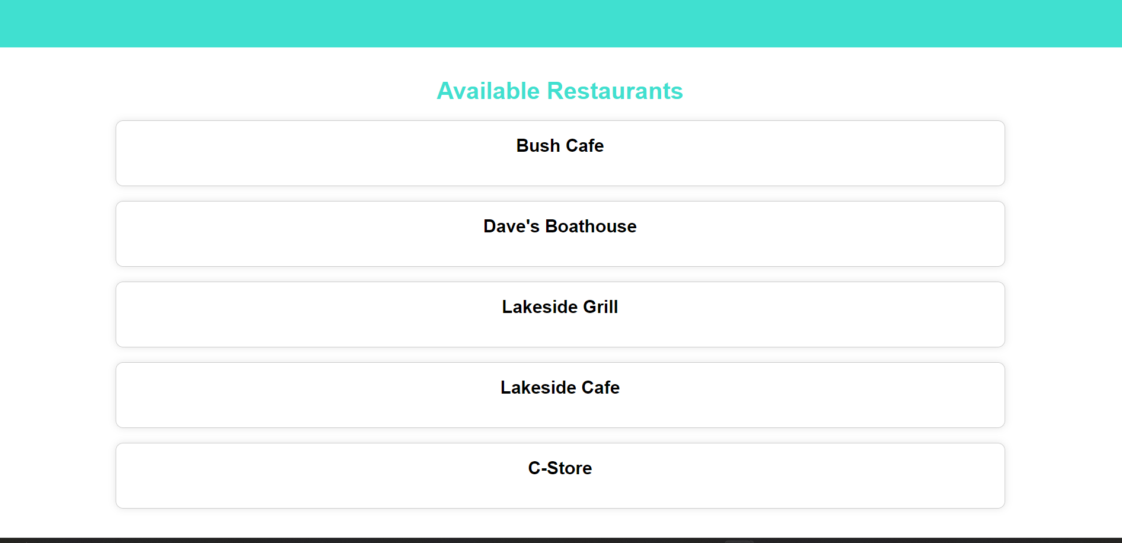

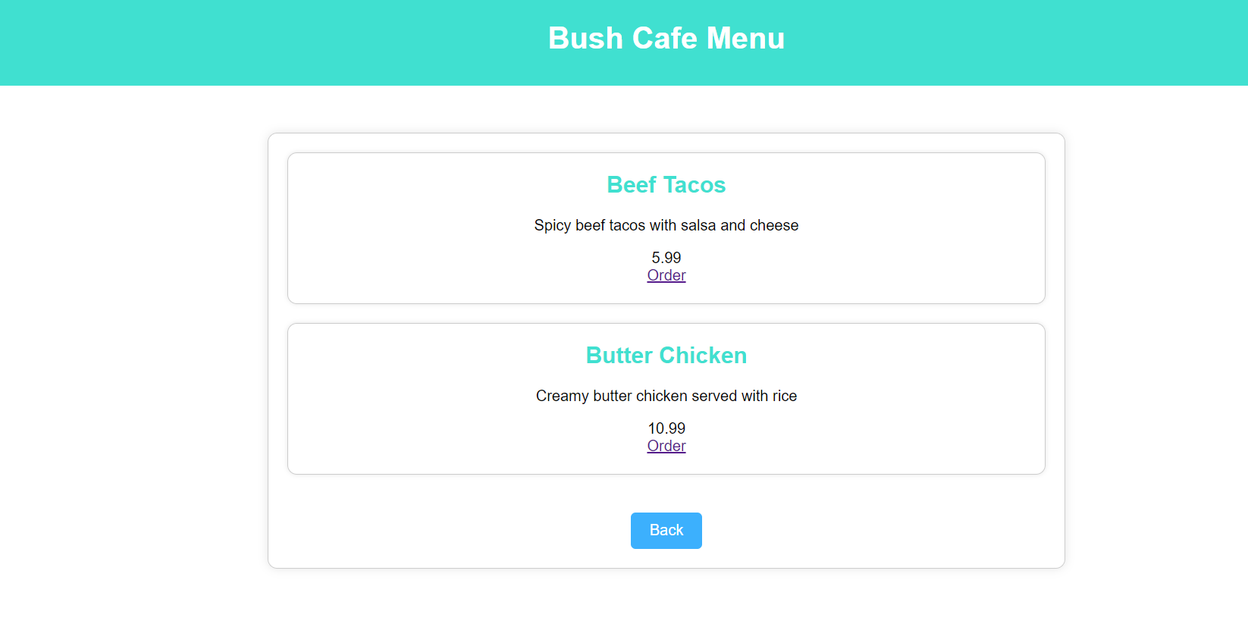

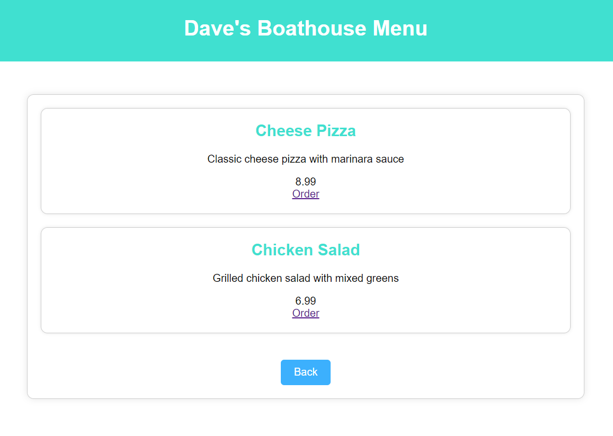

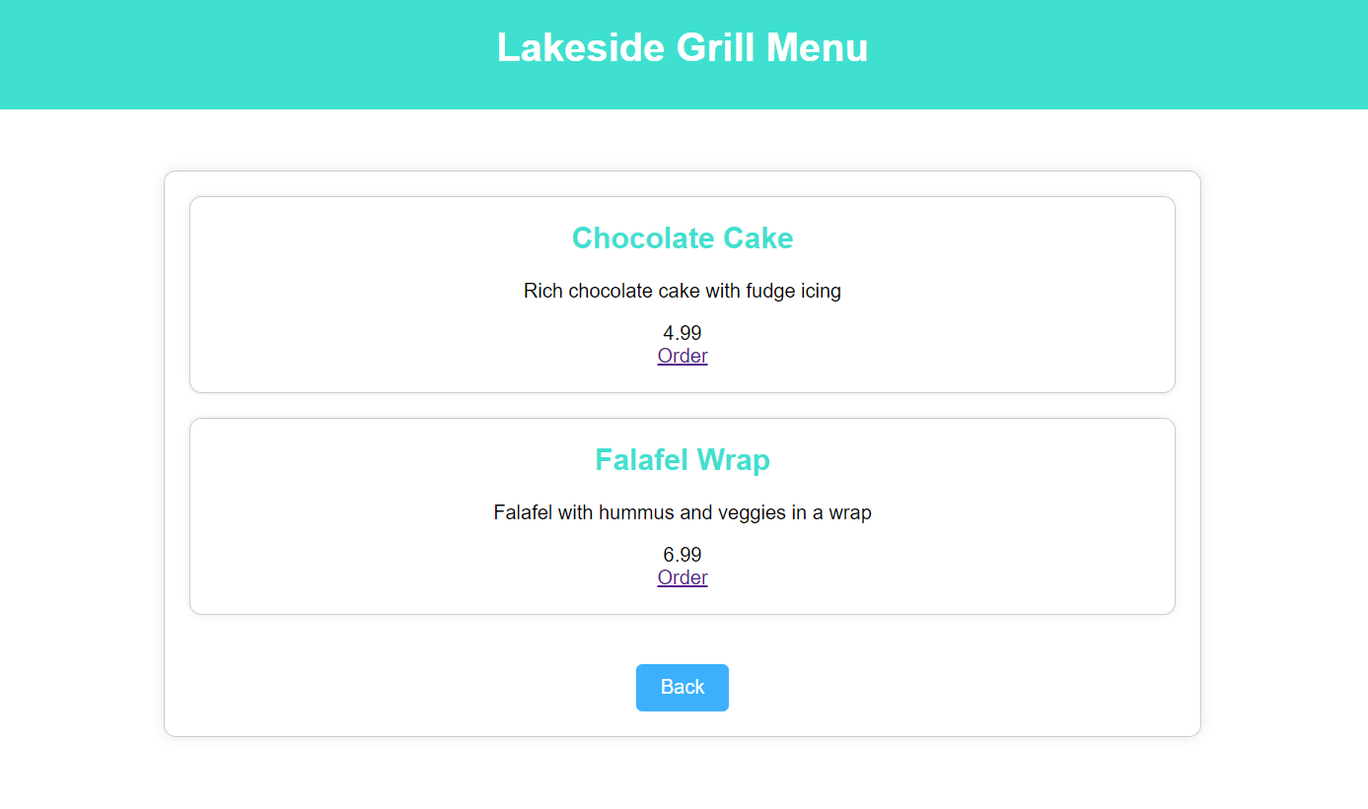

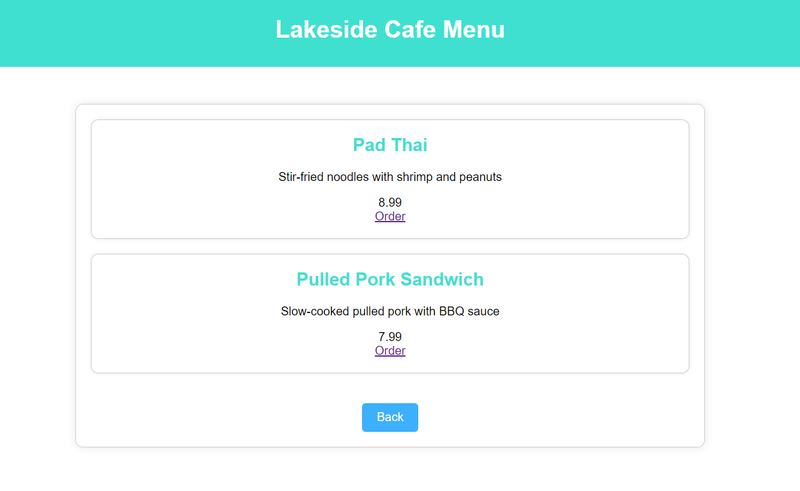

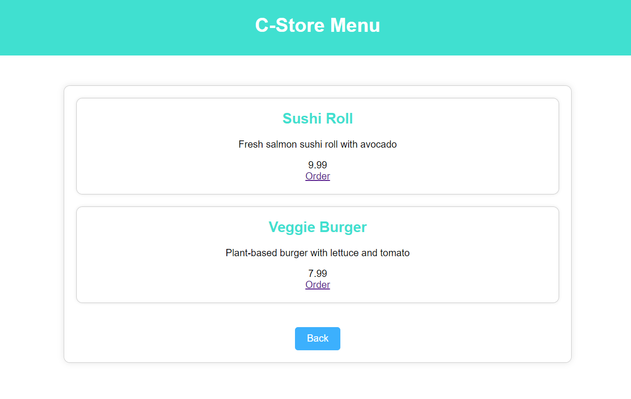

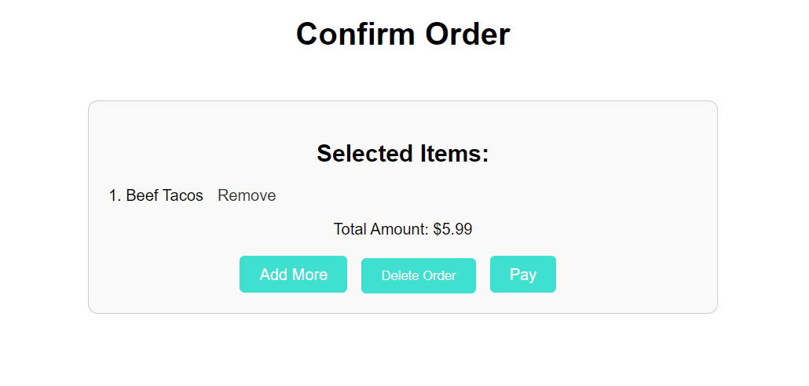

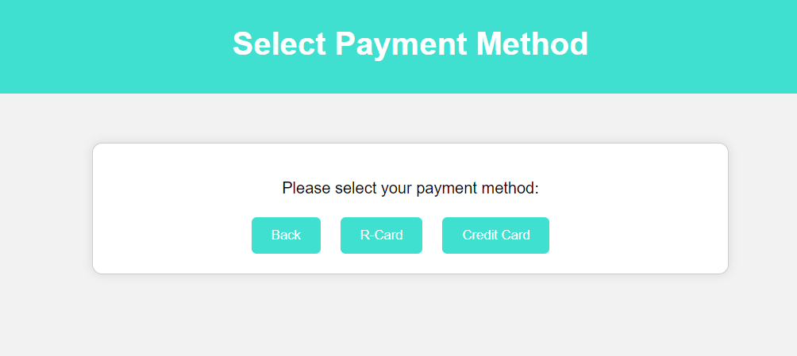

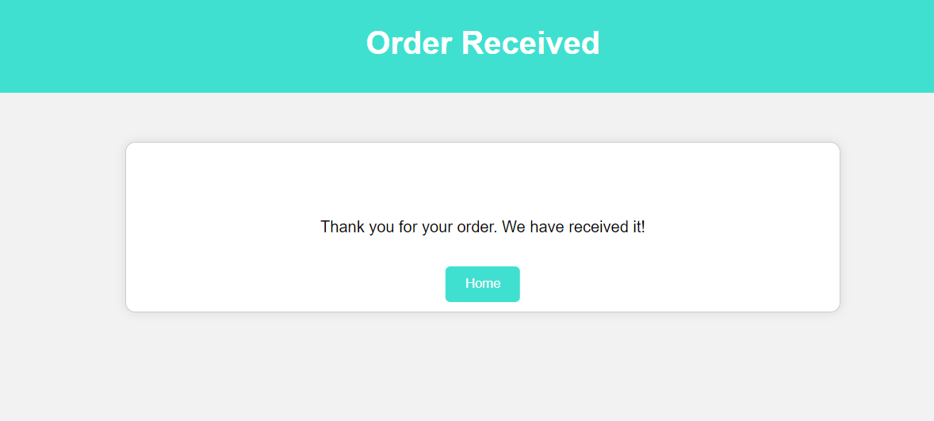

Discussion and Conclusion

In the development of FoxEats, a mobile order application, we encountered numerous challenges starting from the creation of our SQL database. This foundational step required meticulous planning and a deep understanding of the necessary components for an efficient and robust system. Our focus was on designing a comprehensive database schema that could handle various aspects of the application while ensuring data integrity and scalability for future needs.

As we progressed, integrating the SQL database with our locally hosted website presented significant challenges. We employed PHP for server-side scripting to manage data fetching and real-time updates on the website. This approach necessitated careful handling of PHP scripts to ensure smooth communication between the website and the database. The key was to retrieve data efficiently and display it on the website without delays, maintaining a responsive user experience.

Optimizing this interaction was crucial, especially as we aimed to handle potentially high volumes of concurrent users. We focused on refining our SQL queries, utilizing indexing to speed up data retrieval, and implementing caching strategies to minimize database load during peak times.

Security was another major concern. We prioritized safeguarding the application against vulnerabilities such as SQL injection. This involved using prepared statements in PHP, which not only enhanced security but also made our database queries more efficient.

In conclusion, building FoxEats was a complex yet enlightening experience. Each challenge, from database design and PHP integration to performance optimization and securing the application, offered valuable insights into the development of scalable and secure web applications. This project not only honed our technical skills but also deepened our understanding of practical, real-world software development.

References:

Fitzgerald, A. (2024, April 3). *How to make an HTML text box [examples]*. HubSpot Blog. <https://blog.hubspot.com/website/html-text-box>

*How to - login form*. How To Create a Login Form. (n.d.). <https://www.w3schools.com/howto/howto_css_login_form.asp>

*HTML in 100 seconds*. YouTube. (2021, December 3). <https://youtu.be/ok-plXXHlWw?si=TIdXcWk945_cDnW7>

thevanthevan (2018, October 28). *How to validate HTML textbox not to allow special characters and space?*. Stack Overflow. <https://stackoverflow.com/questions/24774367/how-to-validate-html-textbox-not-to-allow-special-characters-and-space>

*Using HTML container tags explained with examples*. codedamn news. (2022, December 4). <https://codedamn.com/news/frontend/using-html-container-tags-explained-with-examples>